**5 Defects encountered in Buggy Cars Rating Website**

Issue 1: For the car that has got the highest number of votes, in the Details grid ,Values under Author column are missing

See Screenshot below, Below Model has got the highest number of votes but Author values do not display

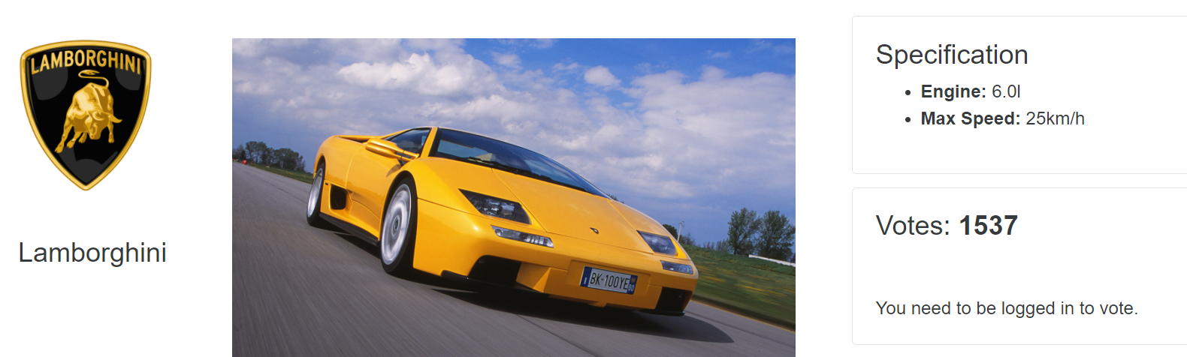

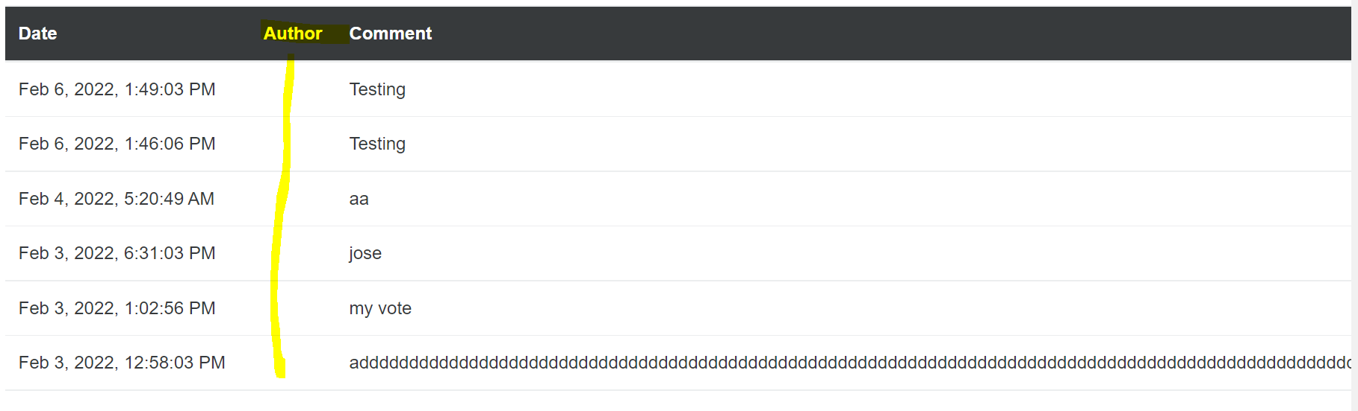

Issue 2: UI Issue

Entering Large texts in the Comment box occupies space and there is NO Validation for the limit in the Comments box

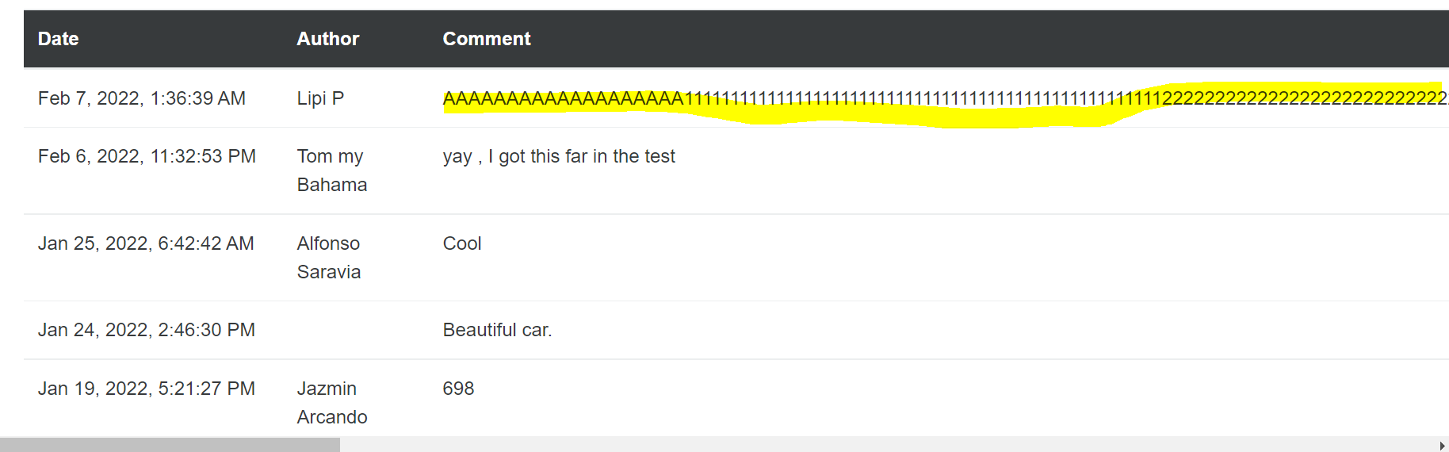

Issue 3 : There is No limit validation for Maximum length for the Phone field on the Settings page

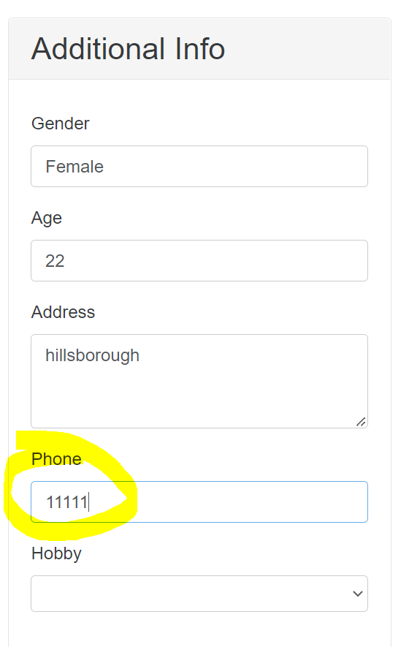

Issue 4 – There is no maximum limit validation on FirstName and LastName fields on Change Profile Page

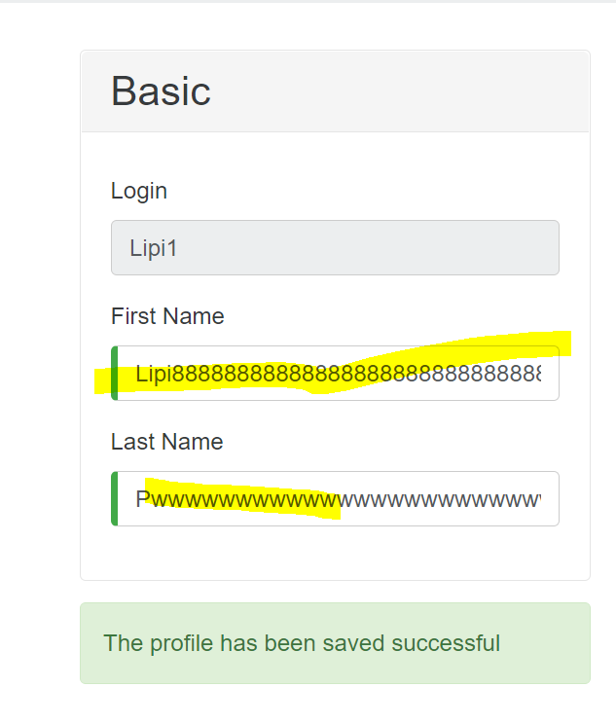

Issue 5 – After Updating FirstName and LastName fields on the Profile Page, the updated FirstName doesn’t show up on the Header and shows the previous FirstName

